Long period:



$$ξ=0.3714>0.04$$

Short period



$$0.3<ξ=0.4831<2.0$$

Then the open loop transfer function is

OL_theta_thetacom =

527 s^2 + 1848 s + 74.13

---------------------------------------------------------

s^5 + 16.43 s^4 + 108.3 s^3 + 441.9 s^2 + 18.57 s + 1.377

Continuous-time transfer function.

Design control loop with PD and PID:

PD_tf =

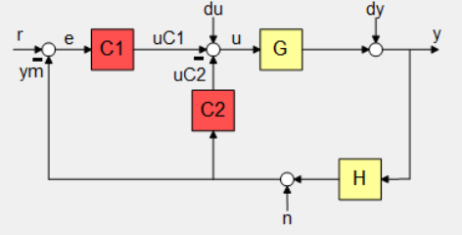 0.085498 s

Name: C2

Continuous-time zero/pole/gain model.

PID_tf =

0.75333 (s+0.6555)

------------------

s

Name: C1

Continuous-time zero/pole/gain model.

Closed Loop transfer function:

CL_theta_thetacom_tf =

From input "r" to output "y":

397 s^3 + 1653 s^2 + 968.6 s + 36.61

------------------------------------------------------------------

s^6 + 16.43 s^5 + 153.4 s^4 + 996.9 s^3 + 1678 s^2 + 970 s + 36.61

Continuous-time transfer function.



Control action transfer function:

C_action_tf =

From input "r" to output "u":

0.7533 s^6 + 12.87 s^5 + 89.72 s^4 + 386.4 s^3 + 232.2 s^2 + 10.21 s + 0.6802

-----------------------------------------------------------------------------

s^6 + 16.43 s^5 + 153.4 s^4 + 996.9 s^3 + 1678 s^2 + 970 s + 36.61

Continuous-time transfer function.

